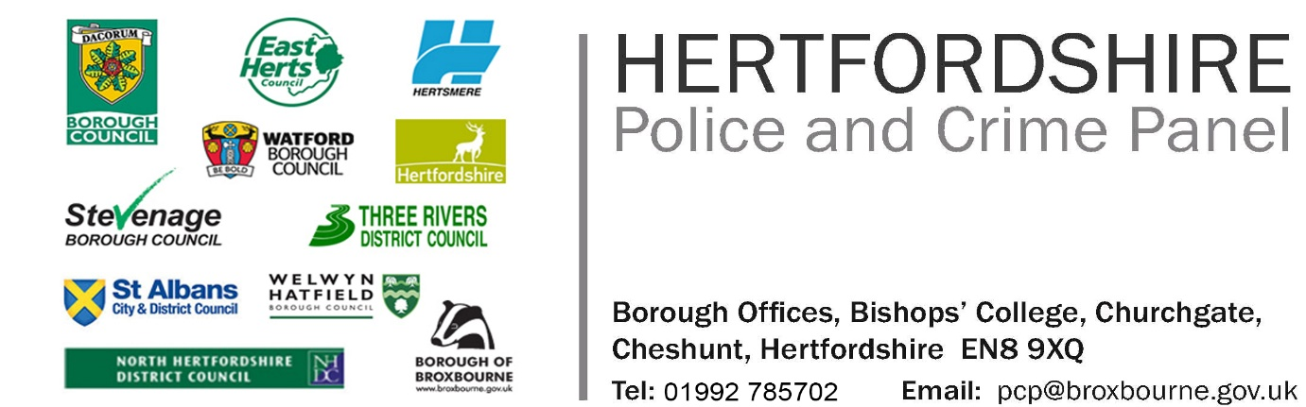

**HERTFORDSHIRE POLICE AND CRIME PANEL**

**Appointment of up to two Independent Members to the Hertfordshire Police and Crime Panel**

Do you live or work in Hertfordshire? Would you like the opportunity to have an input into the scrutiny of policing in the county?

We are looking for members of the public to serve as two independent members on the Hertfordshire Police and Crime Panel. The Panel plays a key role in scrutinising the performance of the elected Hertfordshire Police and Crime Commissioner and promotes openness in the delivery of policing throughout Hertfordshire. Independent members sit alongside Councillors representing Broxbourne, North Herts, East Herts, Stevenage, Three Rivers, St Albans, Dacorum, Watford, Welwyn Hatfield and Hertsmere Councils in addition to Hertfordshire County Council.

Applications are invited from individuals from whatever background who feel that they have the skills, knowledge and experience to undertake this role. An understanding of community safety, policing, criminal justice, budgets and finance would be helpful, but experience in other areas could be equally relevant. The attached role description and person specification briefly outlines the role and responsibility of this position; you may find it helpful to address these responsibilities when you tell the Panel about yourself and the skills and experience you could bring to its work.

The Panel wishes to reflect the breadth of communities in Hertfordshire and welcomes applications from all eligible people irrespective of gender, ethnic origin, religious belief, sexual orientation, disability or age.

As can be seen from the attached role description, the role of a Panel member is an important and demanding one. The Commissioner is required to consult with the Panel on his Police and Crime Plan and the level of Council Tax he wishes to set for the Police each year. The Panel are also consulted over the appointment of senior staff in the Commissioner’s Office and on his chosen candidate for the position of Chief Constable. Panel members could expect to attend 4 to 6 meetings a year, this includes a number of informal meetings with the Commissioner and training events.

Meetings which predominantly take place in the evening, may be held in any of the Council offices in Hertfordshire. Panel members are able to claim reasonable travel expenses. Induction pack will be provided and guidance from the support officers and other Panel Members. The appointment is for an initial period of four years.

For further information on the role of Independent Panel members please contact:

Nathalie Boateng – [Nathalie.boateng@broxbourne.gov.uk](mailto:Nathalie.boateng@broxbourne.gov.uk)

Please watch the Independent Panel Member recruitment video:

<https://youtu.be/P-qbagUzKSs>

Details about the Hertfordshire Police and Crime Panel can be found on its website at: <http://www.hertspcp.org.uk/>

To apply please submit your CV and outline what skills and experience you would bring to the work of the Hertfordshire Police and Crime Panel. In your application, please include your email and postal address together with a contact telephone number. Your CV and any supporting material should be no more than four sides of A4 pages.

The information you provide, may be shared with members of the Police and Crime Panel and Officers from the 11 Hertfordshire local authorities, the information will be treated as confidential, with addresses, phone numbers and any other sensitive information being redacted when appropriate. The information you provide will not be published without your permission.

**The closing date for applications is 5.00pm on Monday 30 September 2024.**

Applications should be submitted to:

[pcp@broxbourne.gov.uk](mailto:pcp@broxbourne.gov.uk)

or

Nathalie Boateng

Broxbourne Council

Legal Services

Bishops’ College

Churchgate

Cheshunt

EN8 9XQ