

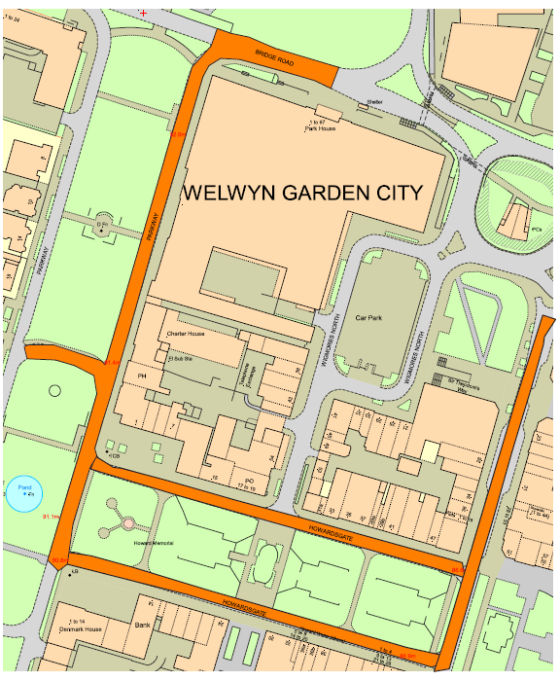
Howardsgate (North)
Howardsgate (South)
Fretherne Road
Stonehills
Parkway link rd
Parkway
B195 The Campus Rbt

Road Closure

TEMPORARY TRAFFIC REGULATION ORDER

WGC
© Crown copyright and database rights 2023 Ordnance Survey 100019606
You are not permitted to copy, sub-licence, distribute or sell any of this data to third parties in any form. (This restriction may not apply to HCC and its licensed contractors, agents & partners.)

