

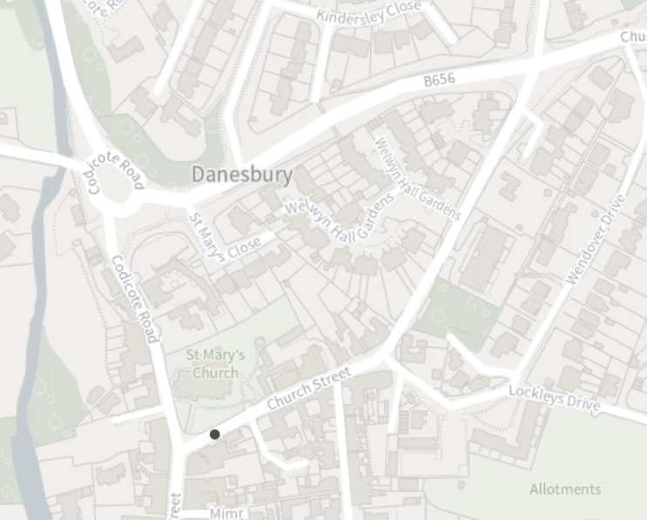
Church Street
Codicote Road
B656 Link Road

Road Closure

Diversion

TEMPORARY TRAFFIC REGULATION ORDER

Church Street, Welwyn
© Crown copyright and database rights 2023 Ordnance Survey 100019606
You are not permitted to copy, sub-licence, distribute or sell any of this data to third parties in any form. (This restriction may not apply to HCC and its licensed contractors, agents & partners.)

